**TEAM ID :** PNT2022TMID12796

**PROJECT TITLE :** Industry-Specific Intelligent Fire Management System

**PROGRAM**

**#include "DHTesp.h"**

**#include <cstdlib>**

**#include <time.h>**

**const int DHT_PIN = 15;**

**bool is_exhaust_fan_on = false;**

**bool is_sprinkler_on = false;**

**float temperature = 0;**

**int gas_ppm = 0;**

**int fire = 0;**

**int flow = 0;**

**String fire_status = "";**

**String accident_status = "";**

**String sprinkler_status = "";**

**DHTesp dhtSensor;**

**void setup() {**

**Serial.begin(99900);**

**dhtSensor.setup(DHT_PIN, DHTesp::DHT22);**

**}**

**void loop() {**

**TempAndHumidity data = dhtSensor.getTempAndHumidity();**

**srand(time(0));**

**temperature = data.temperature;**

**gas_ppm = rand()%1000;**

**int firereading = rand()%1024;**

**fire = map(firereading,0,1024,0,1024);**

**int firerange = map(firereading,0,1024,0,3);**

**int flow = ((rand()%100)>50?1:0);**

**switch (firerange) {**

**case 2:**

**fire_status = "Close Fire";**

**break;**

**case 1:**

**fire_status = "Distant Fire";**

**break;**

**case 0:**

**fire_status = "No Fire";**

**break;**

**}**

**if(gas_ppm > 100){**

**is_exhaust_fan_on = true;**

**}**

**else{**

**is_exhaust_fan_on = false;**

**}**

**if(temperature < 40 && firerange ==2){**

**accident_status = "need auditing";**

**is_sprinkler_on = false;**

**}**

**else if(temperature < 40 && firerange ==0){**

**accident_status = "nothing found";**

**is_sprinkler_on = false;**

**}**

**else if(temperature > 50 && firerange == 1){**

**is_sprinkler_on = true;**

**accident_status = "moderate";**

**}**

**else if(temperature > 55 && firerange == 2){**

**is_sprinkler_on = true;**

**accident_status = "severe";**

**}else{**

**is_sprinkler_on = false;**

**accident_status = "nil";**

**}**

**if(is_sprinkler_on){**

**if(flow){**

**sprinkler_status = "working";**

**}**

**else{**

**sprinkler_status = "not working";**

**}**

**}**

**else if(is_sprinkler_on == false){**

**sprinkler_status = "now it shouldn't";**

**}**

**else{**

**sprinkler_status = "something's wrong";**

**}**

**String out = "{\n\t\"senor_values\":{";**

**out+="\n\t\t\"gas_ppm\":"+String(gas_ppm)+",";**

**out+="\n\t\t\"temperature\":"+String(temperature,2)+",";**

**out+="\n\t\t\"fire\":"+String(fire)+",";**

**out+="\n\t\t\"flow\":"+String(flow)+",\n\t}";**

**out+="\n\t\"output\":{";**

**out+="\n\t\t\"is_exhaust_fan_on\":"+String((is_exhaust_fan_on)?"true":"false")+",";**

**out+="\n\t\t\"is_sprinkler_on\":"+String((is_sprinkler_on)?"true":"false")+",";**

**out+="\n\t}";**

**out+="\n\t\"messages\":{";**

**out+="\n\t\t\"fire_status\":"+fire_status+",";**

**out+="\n\t\t\"flow_status\":"+sprinkler_status+",";**

**out+="\n\t\t\"accident_status\":"+accident_status+",";**

**out+="\n\t}";**

**out+="\n}";**

**Serial.println(out);**

**delay(1000);**

**}**

**DIAGRAM.JSON:**

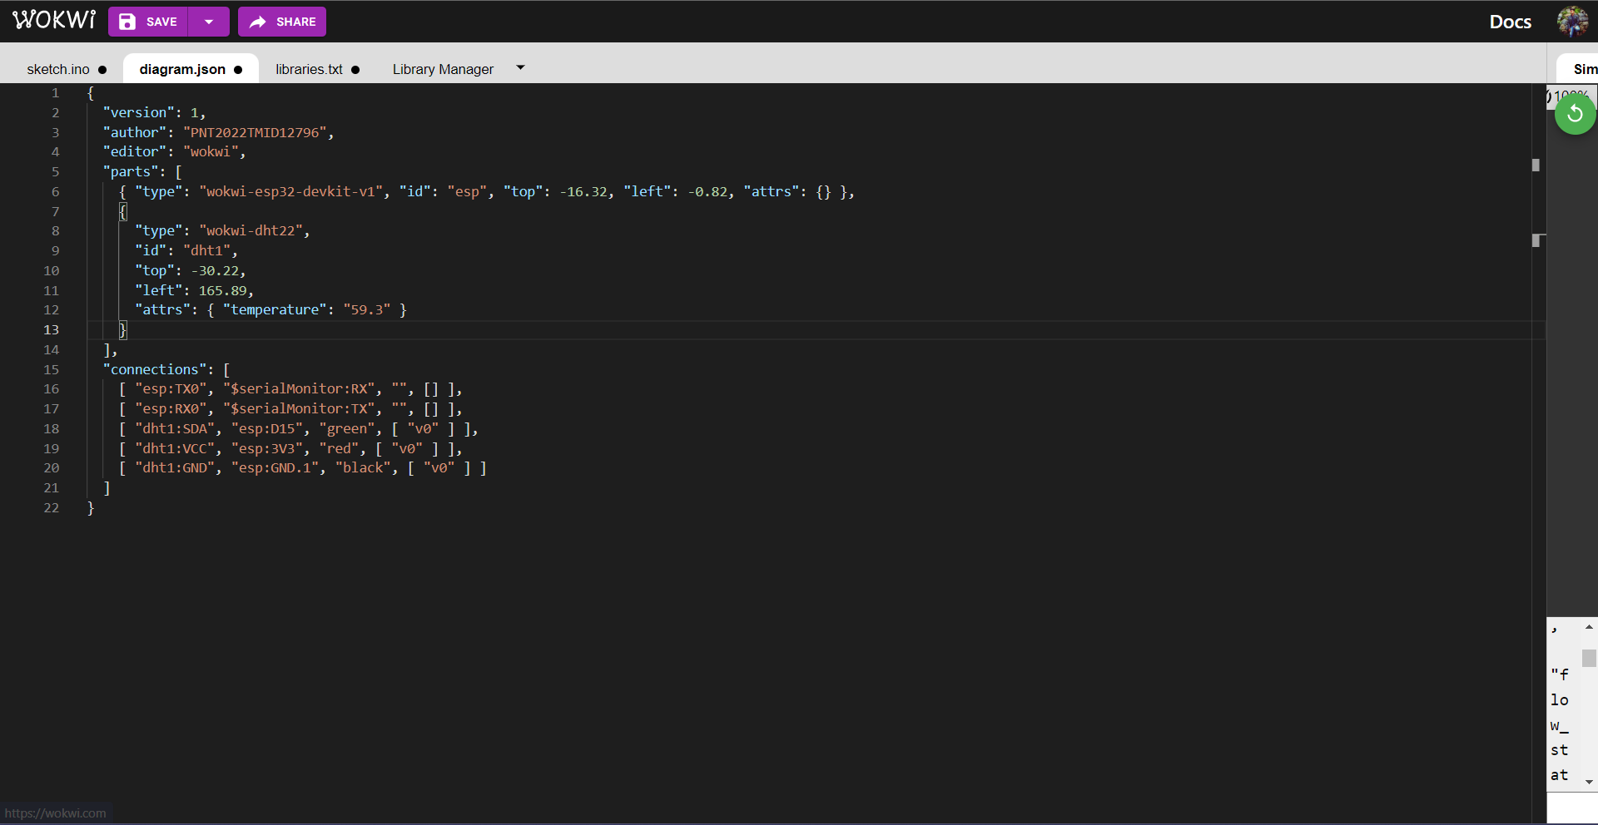

**LIBRARIES TEXT:**

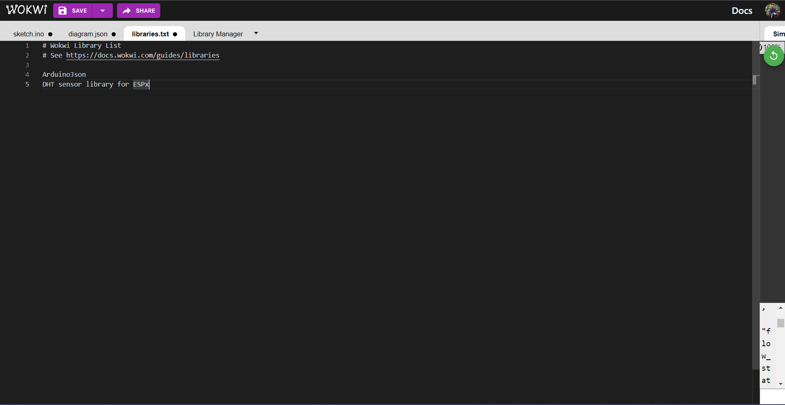

**CIRCUIT:**

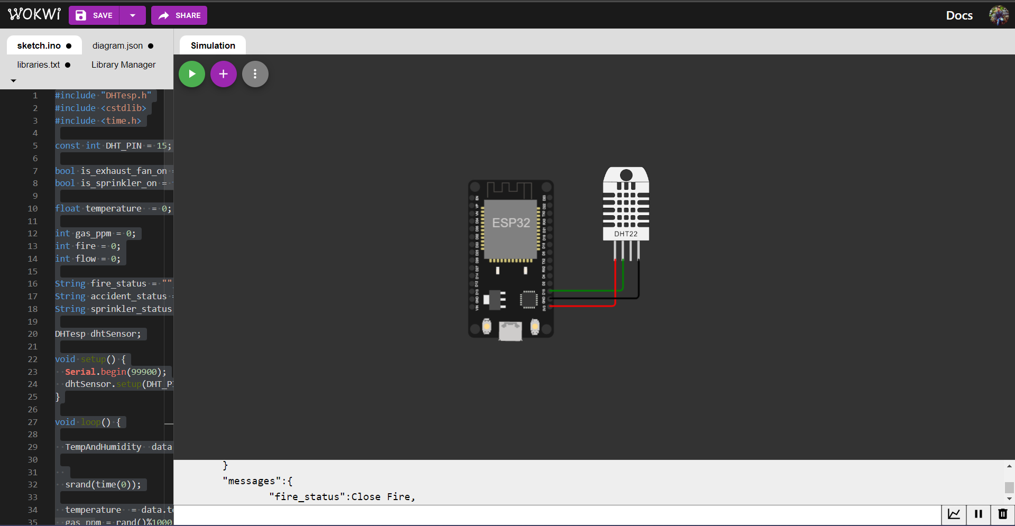

**OUTPUT:**

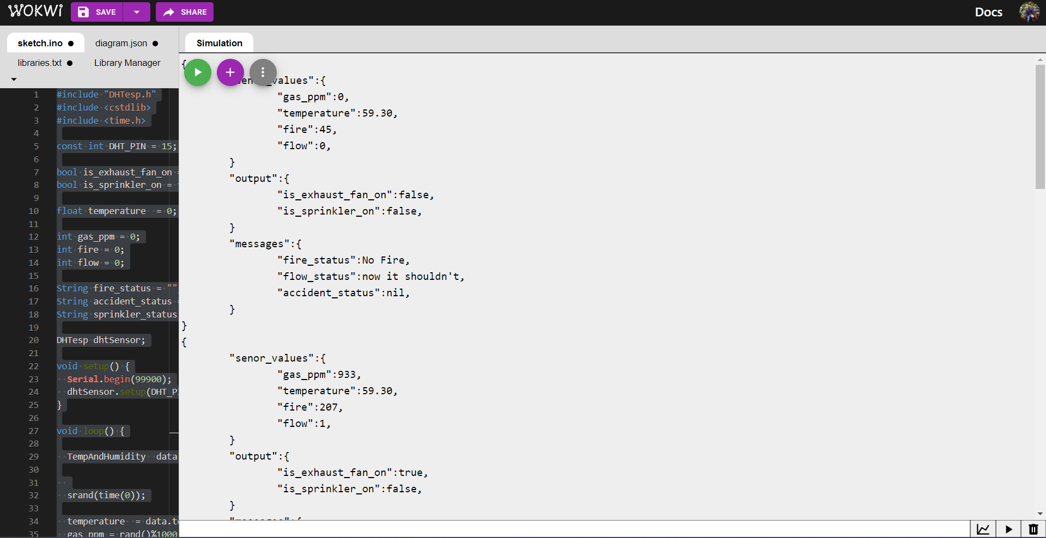

**WOKWI LINK:**

https://wokwi.com/projects/348467067916124756